Name
Instructor
Course
Date
Introduction
The philosophy of existentialism was adopted in the world of art as a way that artists could explore sensory perceptions in their work. In particular, artists wanted to ensure that their work could appeal to the visual and thought processes of their audience. As the word suggests, therefore, existentialism was coined as term to refer to the ‘life’ that pieces of art portrayed. As such, this philosophy emphasized on the need for a piece of art to display a personality and subjective experience as well as the autonomy of the individual being displayed. Consequently, it was under this philosophy that artistic ideas and themes such as anxiety, trauma, and alienation were shaped. This paper shall explore how various artists have adopted and included the philosophy of existentialism in works of painting.
Analysis of Existentialist Paintings
One of the most popular existentialist paintings is that ‘the card players’ by Paul Cezanne.

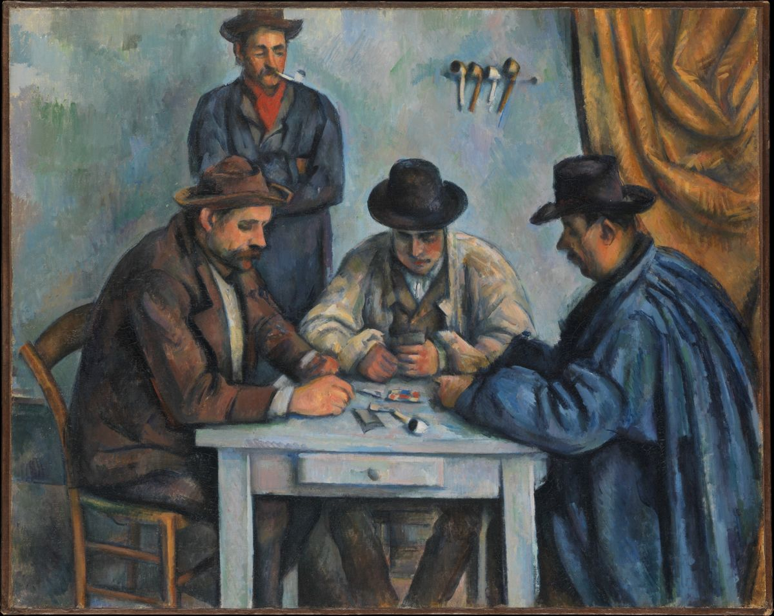
The paintings are a series of men playing cards and is one of the earliest forms of existentialist art. The picture reflects the norm of the time, whereby cards would be played in an environment of food, fun, and drinks. As such, the man standing is smoking from a pot while other pots for smoking can be seen on the wall. The picture also depicts make characters a lone. This represents the situation at the time, where only men would engage in such leisure activities as drinks and games and even if women did engage in similar activities, it was not in the company of the men. Existentialist art is based on the philosophy of freedom and existence. As such, the picture expounds on this understanding, giving men (as represented in the picture), the right to freedom and pleasure of existence devoid of women. A remarkable aspect of the picture and others of the existentialist period is that there were no amused observers of the game. Existentialist art does not only portray what is present, but what was not present. Possibly to imply that only a few people were free and had the discretion to engage in leisure as the men in the picture.
The second existential painting is that of the ‘Head of a Screaming Pope’ by Francis Bacon of 1952. The picture captures a period of harsh motion for the man in the picture, which leads to the distortion of the image as the man screams.

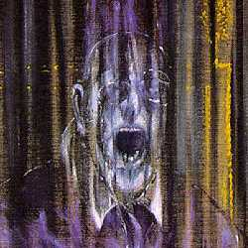
Francis Bacon’s work focused on the post-war era themes for art. The human emotion that bacon displays through the picture is that of hysteria. Being a post-war period, there was a lot of uncertainty, pain, hysteria, and frustration in many people. These feelings are all well captured in the picture. The picture can be further interpreted to imply hysteria not only toward others, but within one self. The man is captured screaming to no one in particular, a possibility that he was angry with himself or his thoughts. The philosophy of existentialism stresses tension between man and his society and there is no better work of art to express this theme than the Head of the Screaming Pope. Existentialists say that man is anguish (Fiero 425),
The third piece of art is that of ‘The Walking Man’ by Alberto Giacometti. Being a post-war era, the painting can be literary interpreted to refer to a man walking to the tragedies and activities of war.
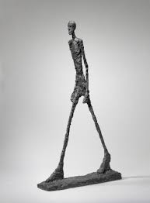
However, a critical look into the picture reveals the fragility and absurdity of the existence of man. The man in the pictured is clearly thin and seemingly weathered by the hardship of his life. However, filled with war and nationalist propaganda, the man is still willing to leave everything behind and take part in the war. This is a satirical expression of the war, which was an exploitation of the people for the prestigious benefits of the rulers of participating nations. Existentialist art focused on matters of human freedom, choice and responsibility (Fiero 424). As man seeks what he considered to be freedom and responsibility, however, he loses himself in the folly that he can achieve these. Apparently, these are elements held and controlled by those in higher ranks of power and they give them sparingly to the common man. Fiero (427) states, ‘Man is constantly outside of himself, in projecting himself, in losing himself outside of himself.
Conclusion
Existentialist art is one of the most remarkable forms of art of all times. Developed after the Second World War, most pieces of art focused on the meaning of human existence and the forces that controlled and guided the existence. To achieve this, most artists employed strategies such as solitude, courage, and self-engagement. This is a feature that is common in the three paintings exhibited above. The screaming face portrays a person that is alone, the same with the walking emancipated man. Although the men playing cards are four, they do not seem to interact with each other much. Instead, they are all well immersed in thoughts regarding the game.

Works Cited
Fiero, Gloria. The Humanistic Tradition: Prehistory to the Early Modern World. MacGraw Hill
Education.

